CHECKLIST FOR
PREPARING PUPILS’ CUMULATIVE RECORDS FOR DIGITIZATION

____ 1. Necessary supplies have been acquired:
- Records Centre storage boxes available from Staples (#STP20657) or Grand & Toy stock # SKU#:BOX
- Electronic Records Transfer List (RTL) form
- Link to online Records Centre Transfer Request System
Detailed instructions for completing the the RTL form are included in the directives for Preparing Pupils’ Cumulative Records.

____ 2. Records have been prepared for digitization:
- Refer to the Records Retention and Disposition Schedule Cumulative Records (Pupil) 1992-EDN-06 for details on what should be included for digitizing. For a copy of the Records Retention and Disposition Schedule see Appendix A in the directives for Preparing Pupils’ Cumulative Records.
- Arrange the group of files by year of graduation, transfer, or withdrawal, followed by student last and first name in alphabetical order.
- Clearly mark the student’s name on the file folders using file labels.
- Remove all paper clips, elastics, staples, sticky notes, etc.
- Flatten any folded paper.
- DO NOT use scotch tape to repair paper.
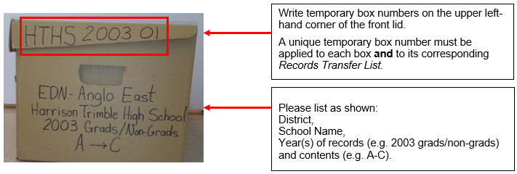
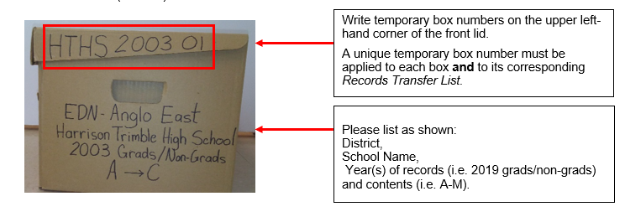
- Remove any blank or unused forms.

____ 3. The boxes have been packed:
- Write a temporary box number on the outside of each box in the sequence the material must be filmed (e.g.: HTHS 2003-01, HTHS 2003-02, HTHS 2003-03, etc.).
- Complete one RTL form per box. A complete list of files is required.

____ 4. Boxes have been sent for digitization:
- Boxes can either be picked up or shipped.
Please note that the sender bears the cost of shipment.
- A Records Transfer Request must be submitted via the online Records Transfer Request System
- Once the Request for Transfer has been approved, the records custodian/sender will receive an email from the system. Records Centre will contact the records custodian/sender one day before pickup.

Note: This checklist and detailed instructions on sending Student Cumulative records to the Records Centre are available under Records Centre Services tab on the Corporate Information Management section of the PANB website: https://archives.gnb.ca/CIM/Default/en-CA

